Project Executable Files

Date | 15 March 2026
Team ID
Project Name | A Comprehensive Measure of Well-Being
Maximum Marks | 3 Marks

Step 1: Submission Checklist

S.No | Item to Submit |  | Submitted (Yes  No / NA) | /
1 | Complete source code (all files and folders) |  | Yes
2 | README / Setup Guide (instructions to run the project) |  | Yes
3 | requirements.txt / package.json / dependency file |  | Yes
4 | Database schema / seed files (if applicable) |  | Yes
5 | Environment configuration file (.env.example similar) | or | No
6 | Deployed application URL (if hosted) |  | NA
7 | APK / Executable binary (if applicable for mobile/desktop apps) |  | NA
8 | Dockerfile / Containerization config (if applicable) |  | NA
9 | Test files and test results |  | Yes
10 | Demo video or walkthrough (if required) |  | Yes

Step 2: File / Folder Structure
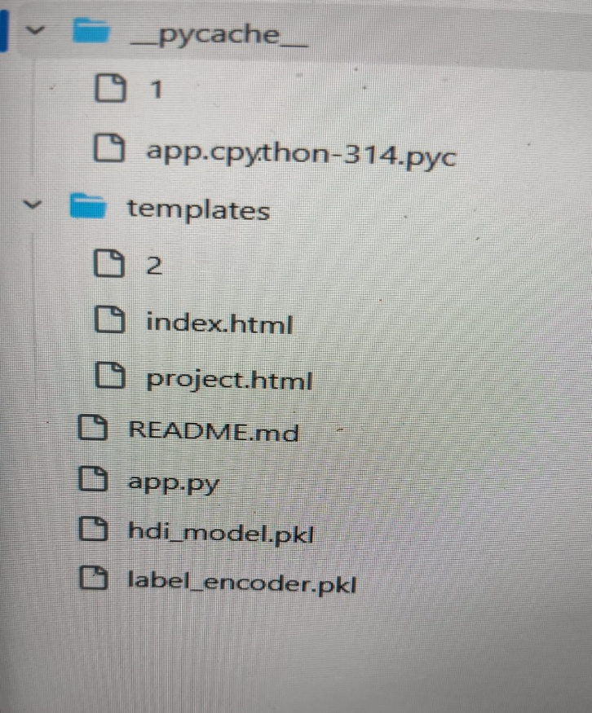

Step 3: Deployment / Access Details

Field | Details
Hosted / Deployed URL | Local Deployment
Login Credentials  (Demo) | There is no Any Login Credentials
Platform / Hosting  Provider | Local Flask Server
Repository Link | https://github.com/sanjana-netizen/HUMAN-DEVELOPMENT-INDEX/tree/main
Demo Video Link

Step 4: Run Instructions

- Gust Open VS code in your System o Open App.py File And Download
- Pip install Flask o Pip install Numpy
- Pip install pickle
- Then Run the Code in the Comment Prompt o Python app.py

Step 5: Known Issues / Limitations

S.No | Known Issue / Limitation | Workaround / Status
1 | Prediction accuracy depends on the quality and completeness of the dataset. | Use a larger and cleaner dataset for future improvements.
2 | The application is designed for local deployment and has limited scalability. | Deploy on a cloud platform such as Render or AWS for better scalability.
3 | The current model uses Linear Regression, which may not capture complex relationships. | Upgrade to advanced machine learning models such as Random Forest, XGBoost, or Neural  Networks in future versions.

